**Hi Marley Accelerator for ClaimCenter 10.12**

Reference Implementation

A Detailed Design Document

Table of Contents

What is included in this accelerator 3

Who should read this document 4

What is not included in this reference implementation 4

Terms of Use 5

Further Assistance 5

Functional Design 6

Functional Overview 6

Open Case in Hi Marley once claim is created with enroll in Hi Marley texting in ClaimCenter 6

Ad Hoc Case Transcript Download 14

Receive Updates from Hi Marley 16

Hi Marley Permissions 18

Technical Design 20

Open Case in Hi Marley 21

Case Close/Open status update from Hi Marley to ClaimCenter 22

Opt-In/Opt-Out status update from Hi Marley to ClaimCenter 23

SMS Message update from Hi Marley to ClaimCenter 24

Hi Marley Note update from Hi Marley to ClaimCenter 25

Update Claim transcript information to Hi Marley 26

Claim updates to Hi Marley 27

Send Claim Closure updates to Hi Marley 28

Automatic Resend Welcome Message to Hi Marley 29

View Hi Marley Case transcript document in ClaimCenter 30

Integration Components 31

Messaging 31

Hi Marley Outbound Integration 31

Hi Marley Inbound Integration 31

Hi Marley Batch Process Integration 31

Data Model Extensions 31

Entity Modifications 31

Typelist Modifications 31

User Interface Modifications 32

Entry/Exit Points 32

Claim Screens 32

Deployment 33

ClaimCenter 33

config 33

gsrc 37

Running this Reference Implementation 39

Known Issues 41

About Guidewire Software 42

# 

Overview

Hi Marley accelerator for ClaimCenter will establish a baseline of packaged and deployable code for insurance carriers utilizing Guidewire ClaimCenter 10.12 and Hi Marley application. Carriers will have the ability to customize and configure ClaimCenter for Hi Marley API services using this accelerator.

The accelerator allows providers to quickly integrate their Guidewire ClaimCenter with Hi Marley, enabling operators (adjusters/underwriters/customer service reps/etc.) to seamlessly include communication via Hi Marley into their everyday life. There are many APIs built to help with this process and minimize any manual work for operators.

The accelerator will function with the out-of-the-box version of ClaimCenter. Included will be Entity Extensions, Web Services, Exception Handling and Validation Rules supporting processes for below use cases.

* Open Case in Hi Marley once claim is created with enroll in Hi Marley texting in ClaimCenter
* Opt-In/Opt-Out status update from Hi Marley to ClaimCenter
* Claim updates to Hi Marley when key fields are changed/updated in ClaimCenter Operator, Adjuster email, Phone number, Privacy)
* Reopen/close update to Hi Marley
* Display Hi Marley details section and navigate to Hi Marley application’s text screen for specific case from ClaimCenter
* Send/Receive SMS messages from ClaimCenter
* Instant download of SMS transcript from Hi Marley within ClaimCenter

## What is included in this accelerator

Following lists the aspects of the solution that will be included in the accelerator:

* Hi Marley Case Creation for claim participant
  1. One claim can have multiple Hi Marley cases (one per claim participant)
* Reassign Hi Marley case(s) when claim owner changes
* Change Hi Marley case(s) when claim action is taken
  1. Hi Marley case(s) closed when claim is closed
* Synchronize data from Hi Marley to Claims Center
  1. New Messages
  2. Download PDF Transcript on case closure or on-demand
  3. Download multimedia files such as images and videos.
  4. Opt-status of claim participant
  5. Hi Marley Case Notes
* Send SMS Messages via Claims Center (template messages or new messages)
* Claims Center admin can configure accelerator in Claims Center
  1. Enable/Disable functionality
     1. Disable files download into claim
     2. Disable Case Transcript download button
     3. Disable Case Visibility Settings
        1. disables all features for setting case to public or private
        2. all cases are public
     4. Disable Case Notes integration
     5. Disable Automatic Operator Creation
     6. Disable Send Message on Claim
  2. Add new SMS template from Hi Marley to Claims Center

1. Limit Hi Marley functionality based on Claims Center permissions
   1. New permissions created for Hi Marley operations
   2. New permissions can be added to new/existing ClaimCenter roles

## Who should read this document

* Carrier Business Sponsors
* Carrier Technical Sponsors
* Carrier ClaimCenter Developers
* Carrier IT Architects

## What is not included in this reference implementation

1. Business specific configurations / configurations for custom ClaimCenter implementations
2. Carrier’s SFTP location implementation
3. Hi Marley’s native user application

* Note that for Guidewire’s functional review, all non-functional requirement (NFR) testing such as Performance, Security, Reliability, Usability etc. is out of scope.

Applicable Product Versions

This accelerator has been developed to work with Guidewire ClaimCenter version 10.12. It has been tested on version10.12 and should work with all minor versions of Version 10 with minimum changes. As currently designed, this version of accelerator will not work with ClaimCenter version 8 or version 9.

## 

## Terms of Use

We have made this document and accompanying accelerator files available to you as we thought that you might find them useful. As such, they are provided to you "as is", which means that we do not offer you any assurances with respect to them. You will be solely responsible for any changes made to your configuration as a result of you downloading and implementing any of our materials.

You also understand that we own the intellectual property rights to any accelerator documentation/file downloads we make available to you. You must not use them in any way that would adversely affect our rights under applicable law.

## Further Assistance

You may wish to make changes to any of the accelerator content provided in this solution. For example, you might want to extend the solution, or to adapt it to suit your unique needs. If during your implementation you require assistance with any of these changes, please contact your Guidewire or partner Implementation Manager to discuss options for consulting assistance.

# Functional Design

## Functional Overview

Following describes the functional objective of this reference implementation:

* Integrate with Hi Marley APIs & Webhooks to give insurance carriers access to Hi Marley platform via Claims Center v9.

Following are functional features of this accelerator:

* Create case (case/actions/open) for any customer on the claim
* Direct link to the conversation in Hi Marley will be noted on the claim in GW after creating the case
* Reflect opt-in status in GW claims user interface (via Hi Marley’s opt in web hook)
* Assign/reassign operator in Hi Marley based on actions in GW
* Close case in Hi Marley on claim closure
* Ability to show all Hi Marley cases in a tabular format with columns including Name, Claim Number, Consent Status, Case Status, Case Privacy
* Redirect to Hi Marley webapp via link URL
* Feature flags – certain integrations/functions that can be enabled/disabled based on carrier preference
* Ability to create message Templates as an Admin
* Live updates of SMS messages into the claim notes (enablement based on webhook subscription)
* Live update of Hi Marley Case Notes into ClaimsCenter in claim notes
* Download Case Transcript and storing into Claims File
* Download Hi Marley Transcript at any time within ClaimCenter
* Close all related cases upon claim closure
* Reopen all related cases upon claim reopen
* Option to change Hi Marley case visibility to either ‘Private’ or ‘Public’
* User experiences changes (“UX Changes”) in reference implementation
  + New Reference Graphic User Interface
  + New Administration Entries

### Open Case in Hi Marley once claim is created with enroll in Hi Marley texting in ClaimCenter

Create Hi Marley Claims Case from FNOL Wizard

1. During FNOL save and Assign user has the option to enroll in Hi Marley texting. Upon selecting that option and completing FNOL, Claim is created. A work item is created for Hi Marley case creation and the information is asynchronously sent to Hi Marley. The work queue processes the work item and once complete, a case is created in Hi Marley and in ClaimCenter.
2. Click on Hi Marley Case in the Navigational Bar on the left of main Claim screen, the case summary screen will appear. Two links created, one for viewing case detail within ClaimCenter, the other for go to Hi Marley web application

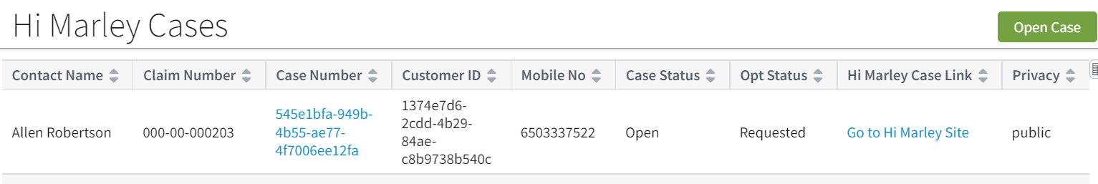

1. When open the Hi Marley Case Details screen, the case initially shown as Requested status. At this status, ClaimCenter user will not be able to do certain functions such as “Opt Out”, “Send SMS”, “Re-Open Case”, etc.

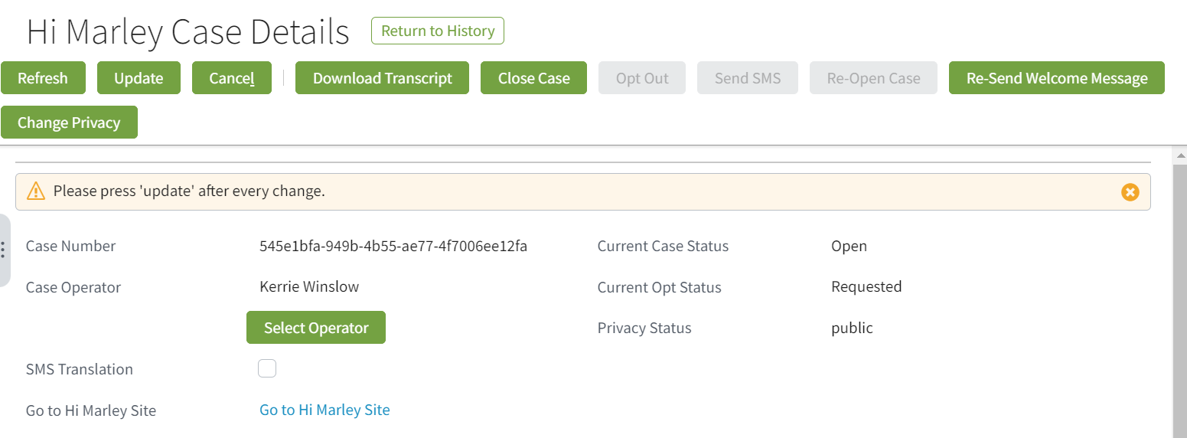

Create Hi Marley Claims Case for any customer on existing open claim

1. In Hi Marley Cases summary screen, click on the “Open Case” button will open the screen to open a new Hi Marley Case in existing claim.

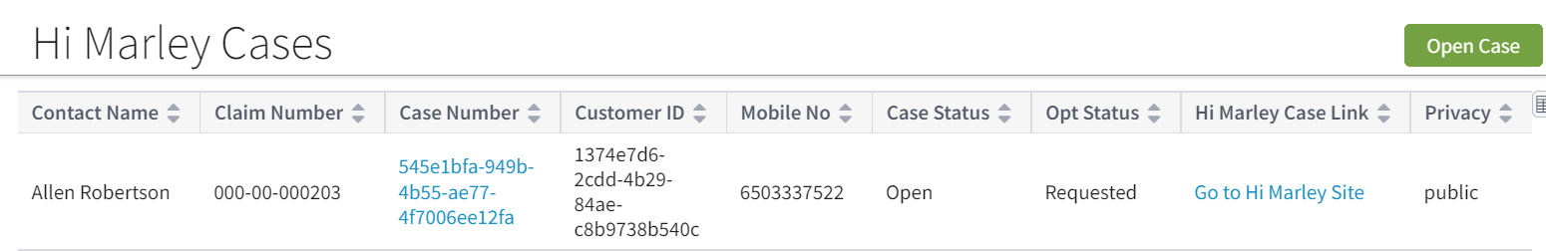

Fill out the form and click on “Create New Case”, it will attempt to open a new case in Hi Marley.

**Note**: This operation could fail if:

* 1. Then phone is not a mobile number
  2. The mobile has more than allowed limit of open cases in Hi Marley (across different claims)
  3. Customer was opt out from other claims

Check log for error detail, if the operation fails

Re-send Welcome Message to Customer

1. Hi Marley, sends welcome text to the end user via SMS when case initiated. If required, user can also re-send the Welcome Message to Customer by clicking on the “Re-Send Welcome Message” button

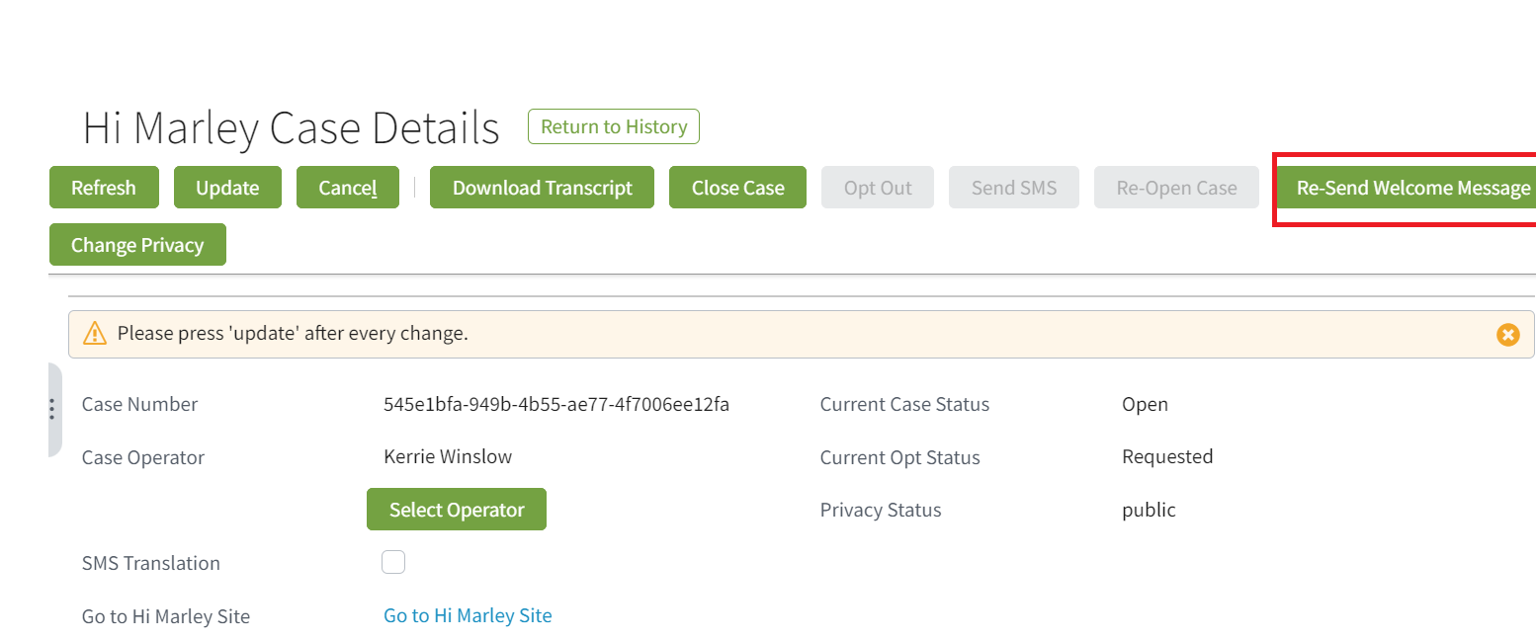

After clicking the button, Hi Marley will resend Welcome Message as shown below in Hi Marley web application:

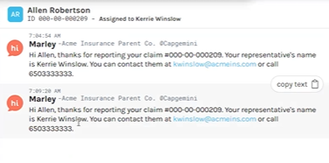

Reflect opt-status of each customer

1. Hi Marley sends customer response as Opt-In status to ClaimCenter.

When customers text “Start” and then “Yes” from their phone, Hi Marley in turn sends Opt-in Status to ClaimCenter and ClaimCenter updates the Opt status.

Following screenshot displays the current opt status of all cases, still in Requested status.

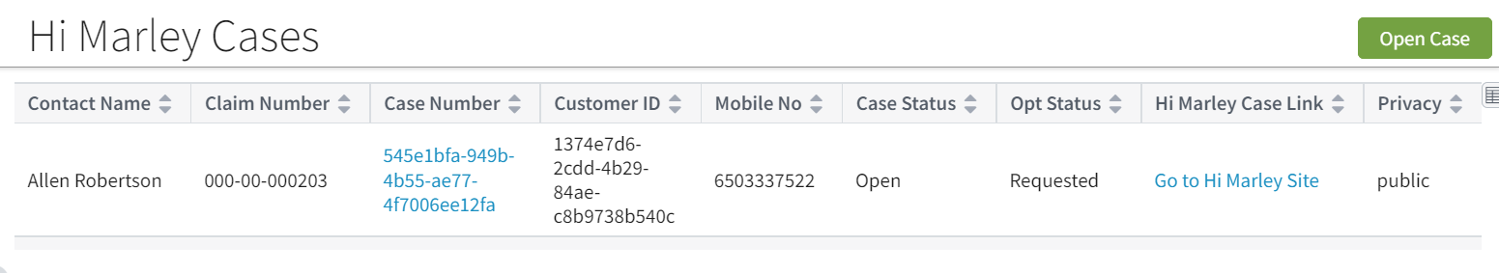

Once the customer has opted in, if ClaimCenter does not automatically refresh the status, selecting the “Refresh” button will update the case to show “opt-in”.

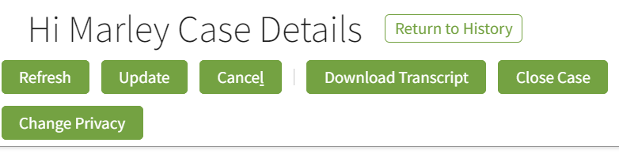

1. Hi Marley, sends customer response as Opt-out status to ClaimCenter. (Opt out from phone)

When customers text “Stop”, the Hi Marley then sends the opt Out Status to ClaimCenter and ClaimCenter updates it as seen in the screenshot below.



Following screen shows the case in Opt-out status:

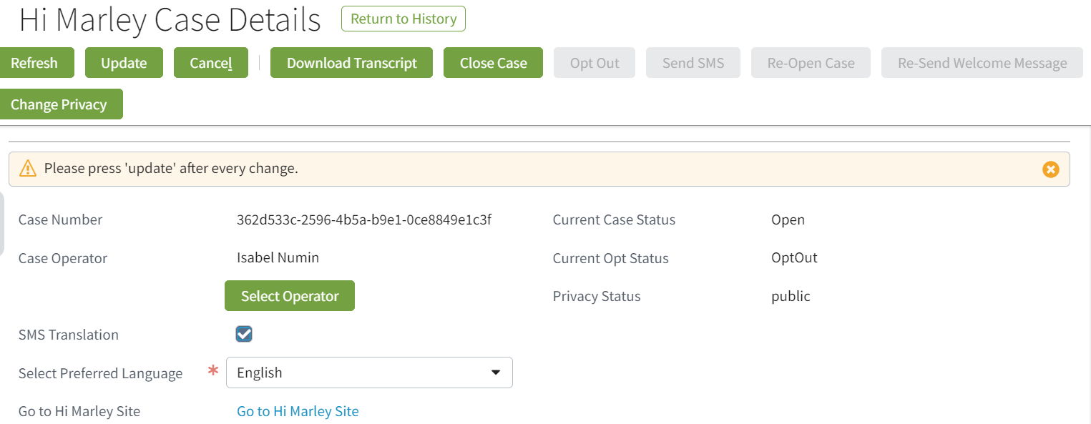

If status is not immediately updated, once the refresh button has been selected, the opt status is updated accordingly.

Sending free text SMS and Sending SMS with templated message

1. Send free text SMS from ClaimCenter

To send an SMS from ClaimCenter, in free text mode, the operator can type a text and hit the send button.

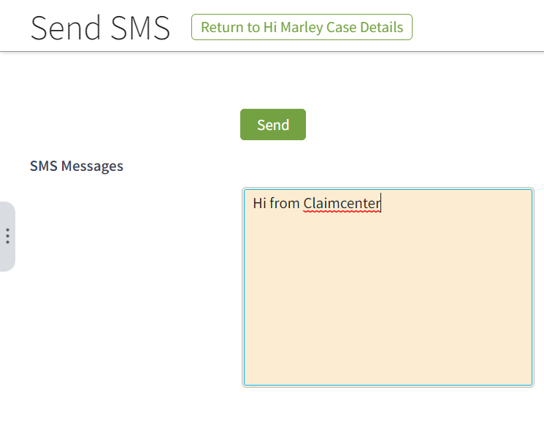

Hi Marley web application also shows this SMS transaction: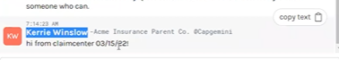

1. Send SMS using Templates

The second way to send an SMS is by selecting a template as seen in the screenshots below.

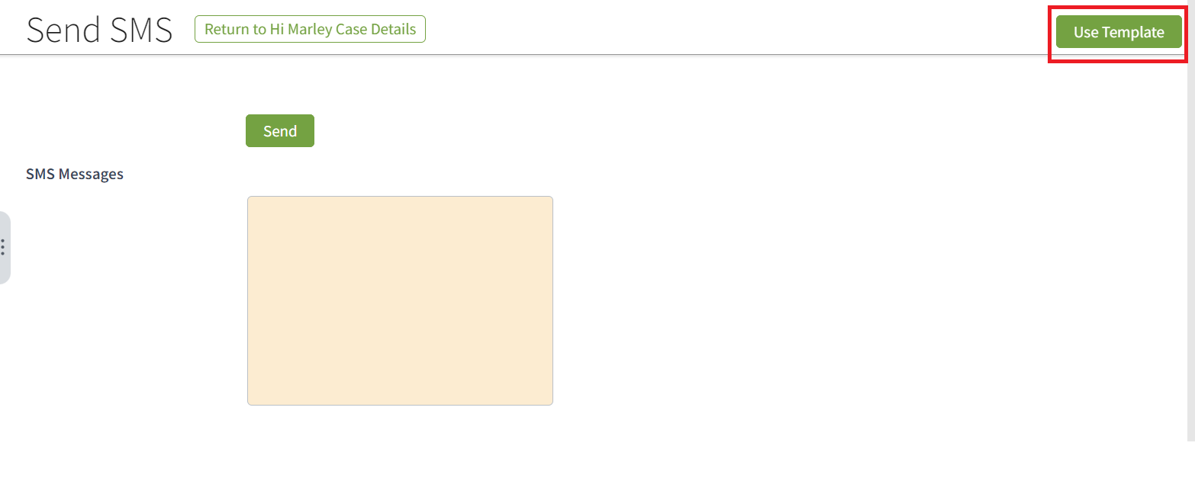

Click on “Use Template”, it will open the “Find SMS Template” screen.

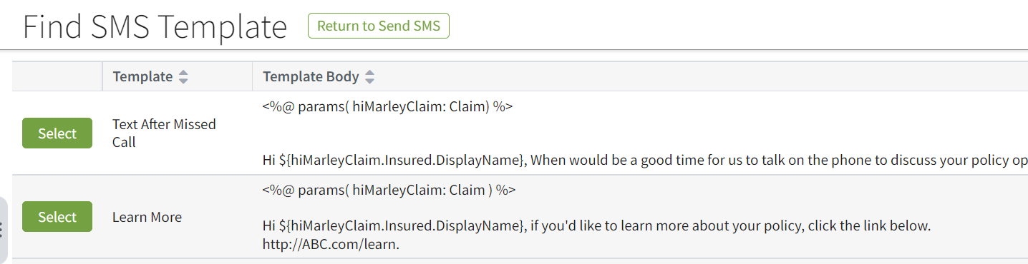

To use any of these templates, click the select button. The text box will be prefilled with the selected SMS template. In this example, the first SMS template has been selected.

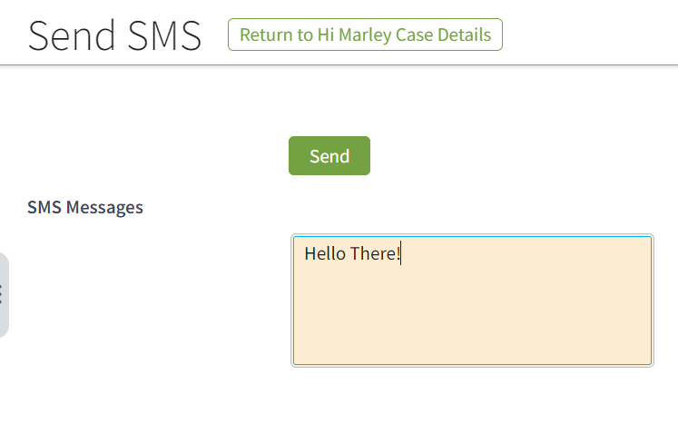

Once sent, Hi Marley will show the SMS with predefined content based on the template.

1. Receiving SMS in ClaimCenter

All SMS messages received in ClaimCenter will be shown as Notes in ClaimCenter. Notes will be added to the Case level as below:

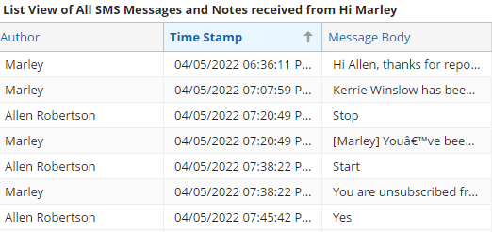

Hi Marley Language translation feature

1. Hi Marely supports auto translation of following languages:

|  |  |
| --- | --- |
| Language | Shorthand – *language Preference* value |
| English (Default) | en |
| Spanish | es |
| Russian | ru |
| Simplified Chinese | zh |
| Korean | ko |
| Portuguese | pt |
| German | de |
| Urdu | ur |
| Arabic | ar |
| Polish | pl |

English is the default preferred language. The preferred language can be changed by clicking the dropdown button and the other language options will be displayed.

Selecting Language Preference:

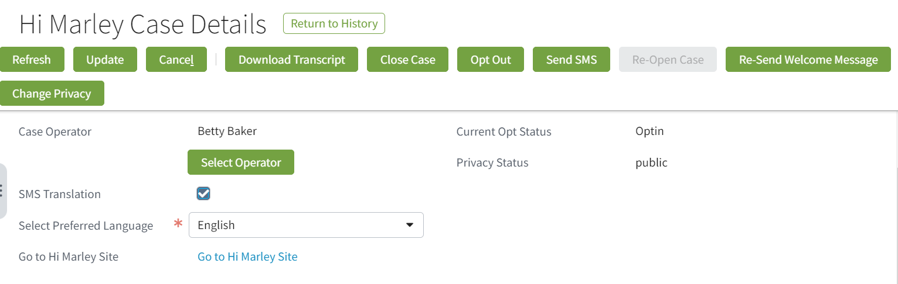

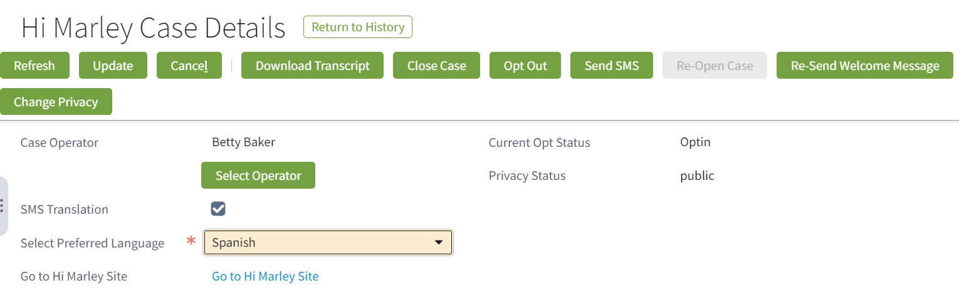

Once a language has been selected, the translation in Hi Marley will be displayed as seen in the screenshot below.

Text in English will change to Spanish on Customer’s phone.

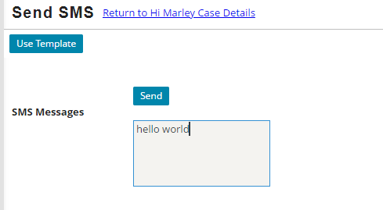

The auto translation here is the result of the Spanish selection for preferred language.

Close Hi Marley Cases

1. Closing Cases individually by selecting “Close Case” button:

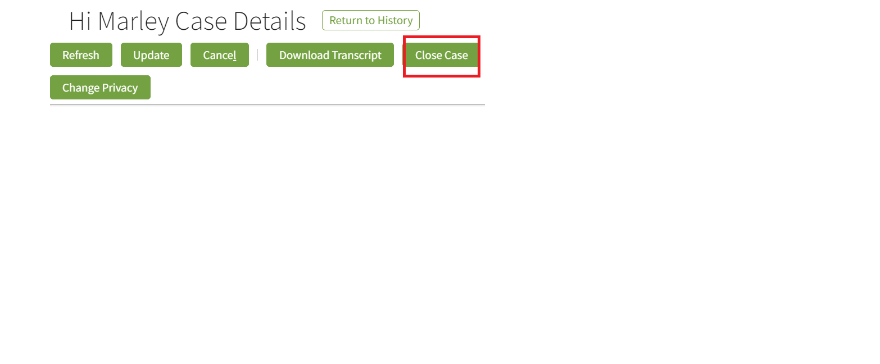

Selecting the close case button will close the case. Case 000103 is the case that will be closed in this example.

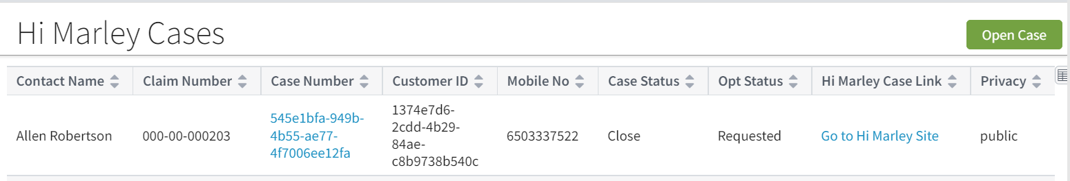

The case status now shows case 000203 as now closed.

1. Closing a claim to all open Cases

To close a claim on open cases, select the workplan tab



Make sure complete/skip all open items  
 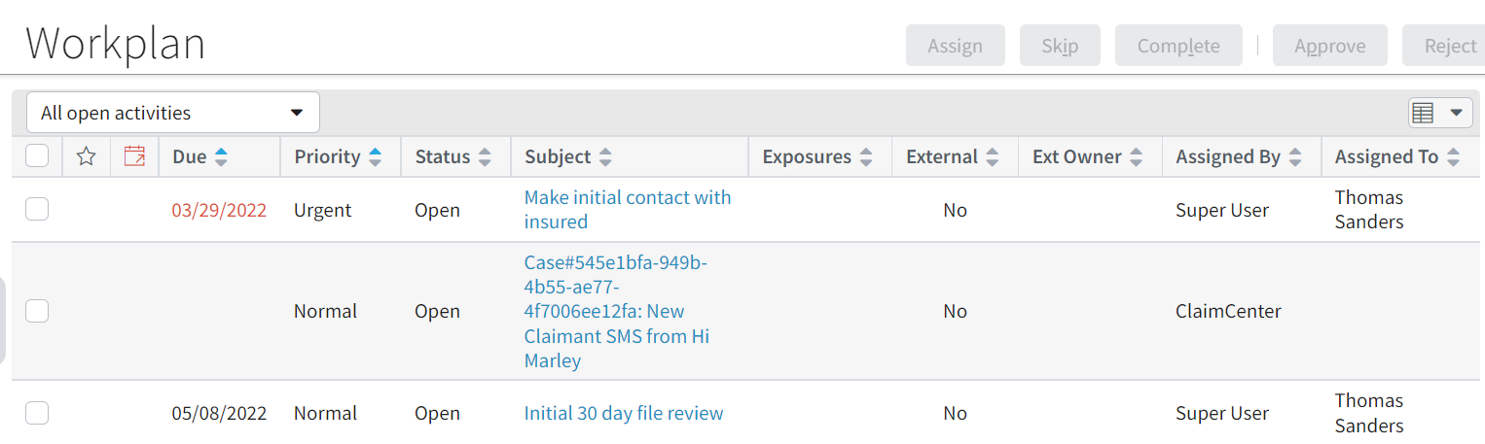

Close Claim, and all Hi Marley cases should be closed in ClaimCenter and Hi Marley



**Note**: Open/Close a claim does NOT affect the Opt status since it is associated at phone number level could across multiple claims.

Re-Open Hi Marley Cases

1. Reopen Cases individually

To re-open the case, select the “Re-Open Case” button.

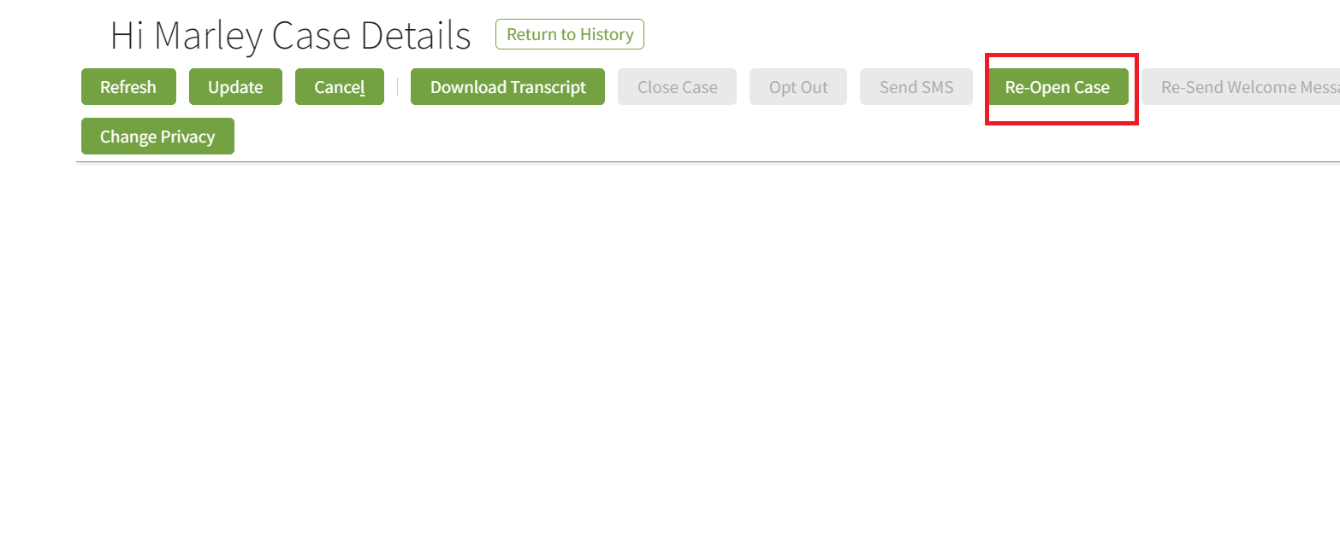

The case status is now showing as opened.

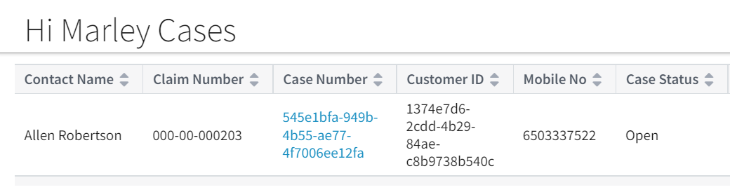

1. Reopening a claim to reopen cases

Select a closed claim, and clicking the “Reopen Claim” button will reopen the claim.



After claim is reopened, all closed cases in the claim should be reopened as well.

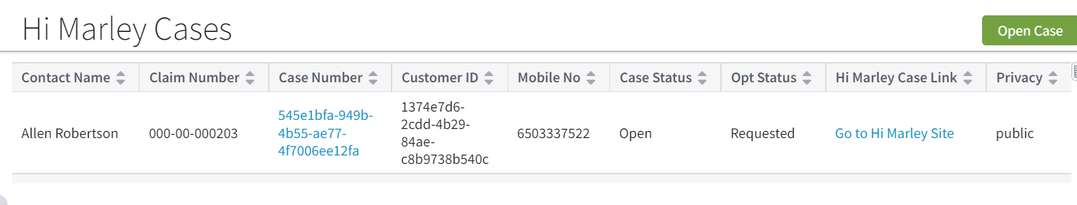

Hi Marley should also reflect on this change.

### Ad Hoc Case Transcript Download

1. Downloading Transcripts

On Hi Marley Case Details screen, click on “Download Transcript” button

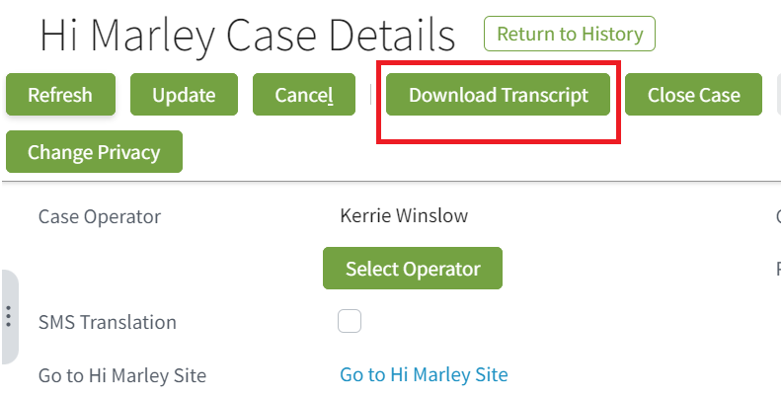

If download is successful, a Confirmation Screen will appear as below:

Newly downloaded transcript will be attached as Claim Level document. To view downloaded transcript, go to “Document” section of the claim by clicking on “Document” in the Navigational bar in the main claim screen.

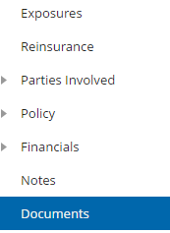

The transcript that is downloaded will be attached inside the document section:

Sample transcript will be a PDF file similar to below:

**Note**: Every Carrier has its own implementation of document management. The transcript downloading approach here is assuming the OOTB document system, which is for reference purposes ONLY. Carrier should implement their own integration for Ad Hoc transcript downloading into their document management system.

### Receive Updates from Hi Marley

1. ClaimCenter will receive updates from Hi Marley via Webhook. This function requires registration of ClaimCenter’s API/Servlet End Points with Webhook. See technical section for registration details.
2. Hi Marley will send SMS messages and Case updates to ClaimCenter. All text based SMS messages and Case updates will be stored as Notes at case level in the claim, as shown below:

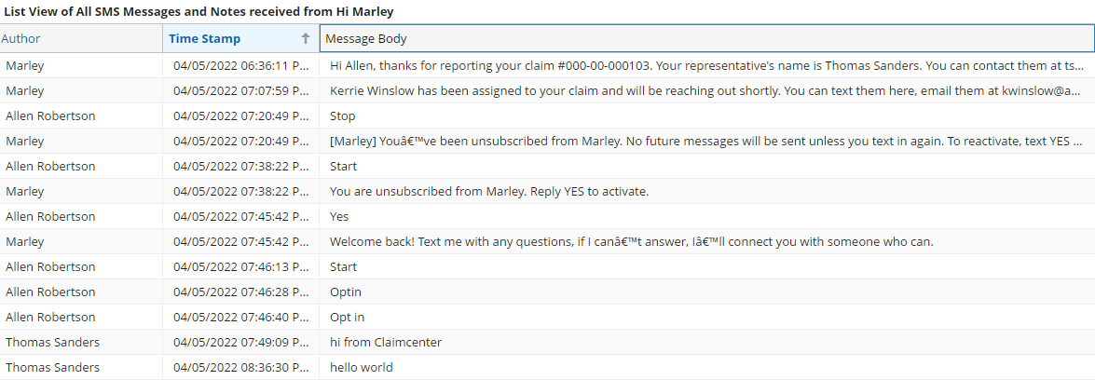

1. Multimedia files such as images and videos will be stored as claim level documents and can be found in Document section.

A sample of image file as below:

**Note**: Every Carrier has its own implementation of document management. The multimedia file handling approach here is assuming the OOTB document system, which is for reference purposes ONLY. Carrier should implement their own integration of multimedia files into their document management system.

Change Case Visibility of Hi Marley case

1. Changing the privacy of a case.

All Hi Marley Cases defaults to “Public” visibility

To change Visibility, choose “Change Privacy” button



The privacy status of the case will now be listed as private

The case detail is only accessible to Super User and Assigned Operator of the Case.

Update operator of Hi Marley case from ClaimCenter

1. Change an operator individually

Click on the “Select Operator” button to change the operator

In next screen, choose new operator from the drop down, and click “Change Operator”:

1. Operator change during re-assignment of Claim. When re-assign a claim from one Adjuster to a new Adjuster, all Hi Marley cases’ operators will change to the new Adjuster if the original operator of the case was same as the previous adjuster. However, any case with non-adjuster operator should remain the same.

**Note**: Both operations may take a while for new operator to be reflect on Hi Marley side since if an operator does not exist in Hi Marley before, ClaimCenter will attempt to register the new operator with Hi Marley first. This auto-registration will fail if this option is turned off in Admin tab hence causing the reassignment fail.

Hi Marley Admin Permissions

1. Change system level permissions in the Admin tab.

Following are system level permissions than can be found under the new “Hi Marley Operator” entry under “Administration”

Each system level permission can be turned on/off by checking its checkbox.

Behaviors of these system level permissions are as follows:

|  |  |
| --- | --- |
| Permission | Behavior |
| Case Visibility | Enable/Disable accessibility of Hi Marley cases |
| Create or Change Operator | Enable/Disable of change/create a case operator |
| Enable Send Message UI | Enable/Disable SMS to allow SMS to be sent from ClaimCenter |
| Enable Live Update | Enable/Disable ClaimCenter receiving SMS messages from Hi Marley via Web Hook |
| Download Transcript | Enable/Disable Ad Hoc Downloading of Transcript |
| Automatic Sync Notes | Enable/Disable ClaimCenter receiving Hi Marley case updates |
| Enable Send Template | Enable/Disable using template for sending SMS from ClaimCenter |

1. Change duration of “Automatically resend Welcome SMS”. This option is default to 24 hours after the first “Welcome SMS” is sent. User can adjuster this number to required duration by business.

**Note**: By default, none of the permission is turned on. Please turn on these permissions when enabling Hi Marley in carrier’s implementation after deployment to an environment.

### Disable Hi Marley messages in Claim Notes

### 

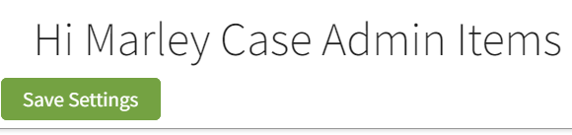

To Disable Hi Marley Case notes in Case Details from syncing, uncheck the ‘automatic sync notes’ and then select the ‘save settings button.’

### Sending SMS as "Super User" will throw an "unknown" does not exist error (new)

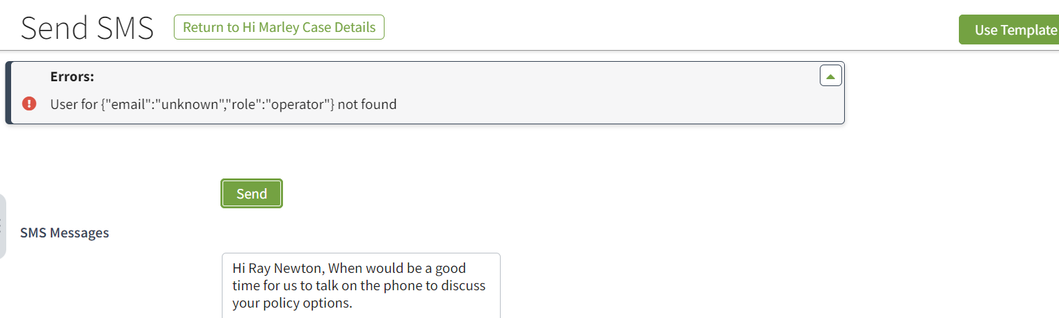

When the “Super User” is selected as the operator, the error message above will be received.

### Disable Hi Marley Messages in Claim notes.

### 

To disable Hi Marley messages in claim notes, uncheck the enable live update flag feature.

### Hi Marley Permissions

1. Following Hi Marley permissions were created and can be added to any ClaimCenter role:

**Note**: Although these permissions can be added to any ClaimCenter role, in order to show clear responsibility for handling Hi Marley cases, it is recommended that Carrier to create a new “HiMarley Operator” role with these permission added during implementation time.

Administration of SMS Templates

1. Add/Remove SMS templates

Select new “Hi Marley Operator” entry under “Administration”, then choose “Hi Marely Case Admin Add/Remove Template” in Navigational bar on the left:

This will show the list of templates that can be used by SMS.

Select existing Template can allow it to be Deleted.

Clicking on “Add Template” will open the “New Template” screen to add new template:

**Note**: SMS templates use same syntax as ClaimCenter’s “Template” object.

**Note**: SMS templates can only be added/removed but NOT editable.

# Technical Design

Technical Overview

Following provides a high-level overview of the architecture of this reference implementation.

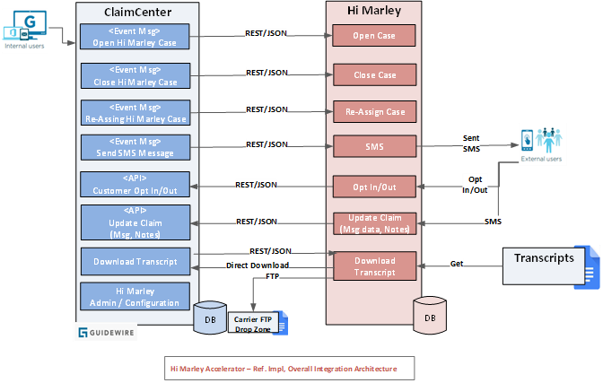

As shown in above reference implementation diagram, ClaimCenter and Hi Marley will be integrated via the Hi Marley accelerator leveraging a direct client-server architecture.  Any middleware tier implementation will be the responsibility of carrier.

ClaimCenter will consume APIs exposed by Hi Marley to perform required functions (i.e. Open case, Close case, assigning case, send SMS, etc.)

ClaimCenter also will expose APIs and Plugins to allow Hi Marley to perform required functions (i.e. Send Customer data, Send messages, Download case transcripts, etc.)

Since this accelerator will be based on previous accelerator for ClaimCenter v9.x, for downward compatibility, this accelerator will inherit application and integration architecture from previous accelerator unless unique new features in ClaimCenter v9bb.x can significantly improve the functionality, reliability, and performance of the accelerator.

### Open Case in Hi Marley

ClaimCenter events will trigger an integration between ClaimCenter and Hi Marley. This integration will invoke Rest webservice call and notify Hi Marley of an event and Hi Marley sends text message to the Claimant accordingly.

• Guidewire ClaimCenter has an OOTB event where, when a claim creation is finished that event gets triggered at initial stage in the Claim lifecycle (FNOL).

• When this OOTB event is triggered, an Event Fired rule will be invoked with Open status which sends a JSON Payload to a predefined messaging destination configured in ClaimCenter. The event fired rule is an OOTB feature in GW rules engine

• This Messaging destination will use a Message Asynchronous Transport plugin that will be used to send the message about the claim information to Hi Marley.

• Hi Marley will use the message sent from ClaimCenter to create a text message that will be sent to the Claimant.

**Open Case from FNOL**

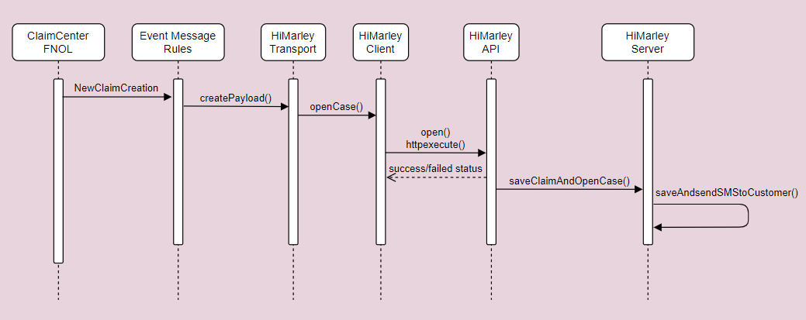

**Open Case from an existing Claim**

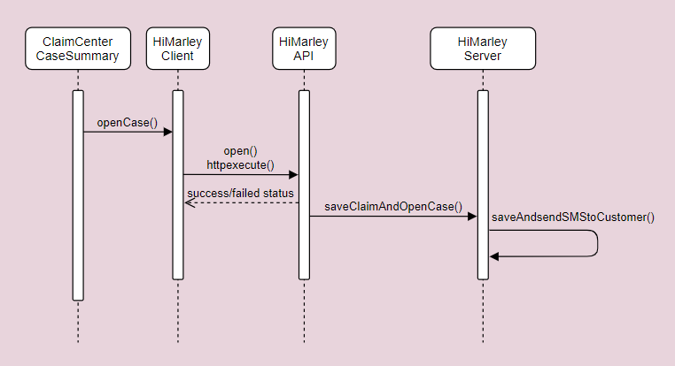

### Case Close/Open status update from Hi Marley to ClaimCenter

Subscription to webhook sends updates back to carrier system based on changes in Hi Marley (case close/open).

Hi Marley sends update to ClaimCenter whether Hi Marley case is closed or reopened. Based on webhook status, ClaimCenter updates Hi Marley details in ClaimCenter.

Carrier has to subscribe to Hi Marley webhook to update Hi Marley case details in ClaimCenter.

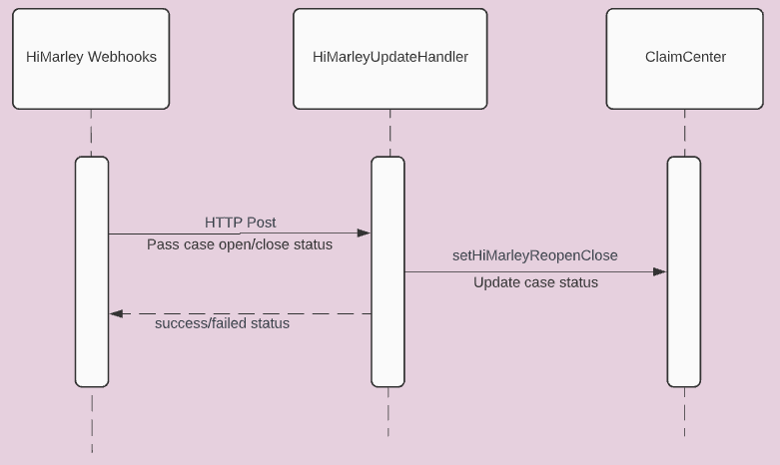

### Opt-In/Opt-Out status update from Hi Marley to ClaimCenter

Subscription to webhook sends updates back to carrier system based on changes in Hi Marley (user opt in/out).

Hi Marley sends update to ClaimCenter whether Customer Opted or Opted out. Based on webhook status, ClaimCenter updates Hi Marley details in ClaimCenter.

Carrier has to subscribe to Hi Marley webhook to update Hi Marley case details in ClaimCenter.

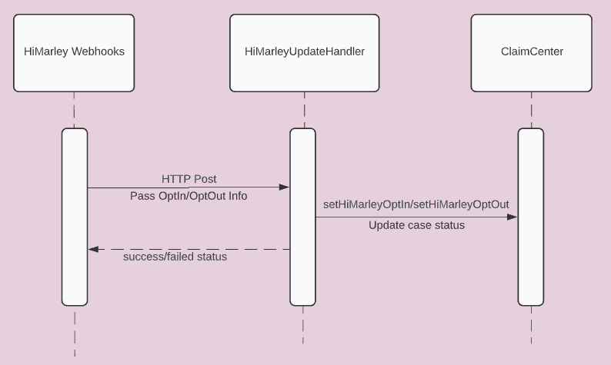

### SMS Message update from Hi Marley to ClaimCenter

Subscription to webhook sends updates back to carrier system based on messages received and sent in Hi Marley.

Hi Marley sends update to ClaimCenter whenever Operator, Claimant, or Hi Marley AI sends or receives a message. Based on webhook status, ClaimCenter updates Claim Notes in ClaimCenter and adds to corresponding Case message list.

Carrier has to subscribe to Hi Marley webhook to update Hi Marley messages in ClaimCenter.

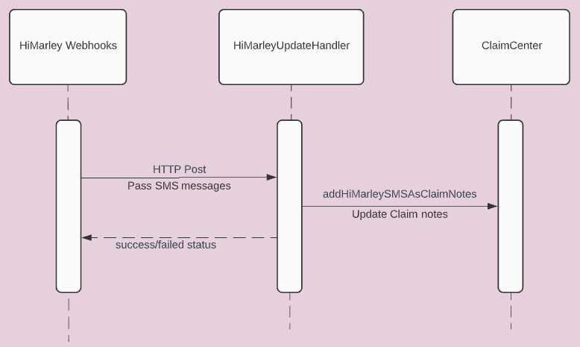

### Hi Marley Note update from Hi Marley to ClaimCenter

Subscription to webhook sends updates back to carrier system based on notes updated in Hi Marley.

Hi Marley sends update to ClaimCenter whenever Operator makes a note. Based on webhook status, ClaimCenter updates Claim Notes in ClaimCenter.

Carrier has to subscribe to Hi Marley webhook to update Claim notes in ClaimCenter.

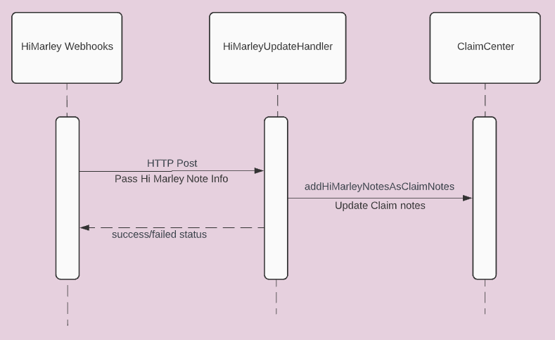

### Update Claim transcript information to Hi Marley

Download transcript – Initiates the download transcript call to save case transcript PDF to ClaimCenter Documents

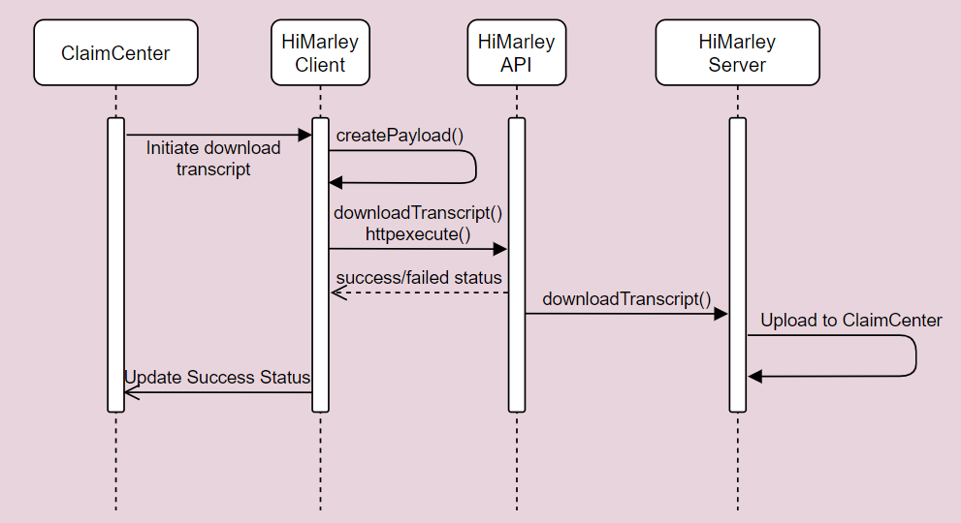

### Claim updates to Hi Marley

Assign/Reassign operator, Change Privacy, Turning On/Off Auto-Translation, Claimant OptOut Status, and Case Open/Close Status–triggers update to Hi Marley

The body of the request must include a primary Contact and one of email/mobile/id for that identity and the case id which may be required in the url parameter instead.

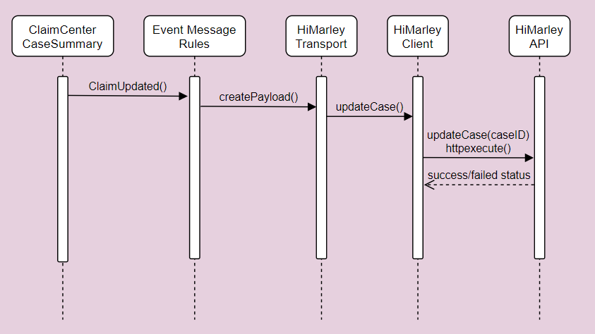

### Send Claim Closure updates to Hi Marley

Close case – Once ClaimCenter closes a Claim, Claim Close request is sent to Hi Marley. Hi Marley closes the case in their application.

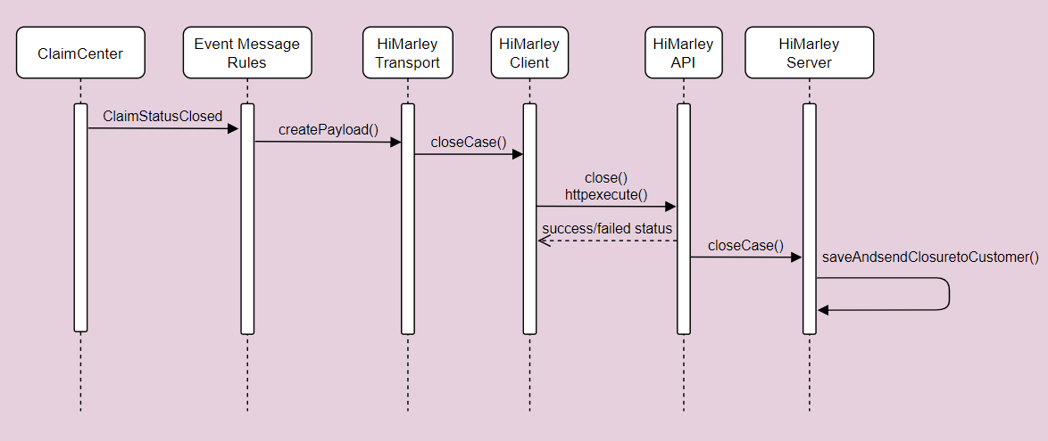

### Automatic Resend Welcome Message to Hi Marley

Automatic Resend Welcome Message – Every period (default to 24 hours), Welcome message request is automatically sent to Hi Marley by batch process. Hi Marley Operator can change the time to resend Welcome message. Resend Welcome message is only sent to Claimants that have not opted in (in the request phase).

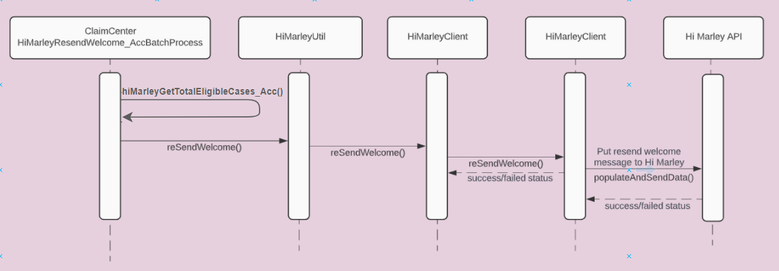

### View Hi Marley Case transcript document in ClaimCenter

Once Hi Marley Transcript downloading Process is run, it creates a document entity, and attach document to Claim. ClaimCenter retrieves the document and displays under Documents tab along with other documents.

**Note**: This approach is assuming OOTB document management solution, and it is for reference only. Carrier must implement their own document management solution

## Integration Components

### Messaging

### Hi Marley Outbound Integration

* Uses Message Transport and event fired mechanism to send messages to Hi Marley by consuming Hi Marley REST API

### Hi Marley Inbound Integration

* Servlets that subscribe to Hi Marley webhook to receive update from Hi Marley for:
  + Case Open/Close status
  + OptIn/OptOut
  + SMS detail
  + Hi Marley case notes
  + Transcript

Future JSON payload field additions would require changes to the corresponding schema:

* 1. Go to the corresponding schema:

<ClaimCenter Installation Root>\ modules\configuration\config\integration\schemas\acc\himarley

* 1. Follow the format in the schema file to add the additional field. Example:

"fieldName": {

"type": "object",

"additionalProperties": {

"type": "string"},

"properties": {

"property1": {

"type": "string"

}}}

* 1. For nested fields, do like:

"FieldName": {

"type": "object",

"additionalProperties": {

"type": "string"},

"properties": {

"aFieldName": {

"$ref" : "#/definitions/fieldName"

}}}

### Hi Marley Batch Process Integration

* Batch Process read and generate transcript document
* Batch process resends welcome message to claimant after a number of hours, default is 24 hours

## Data Model Extensions

### Entity Modifications

* **Claim.HiMarley.etx -** Newentity extension added with one-to-many relation to HiMarleyCaseData_Acc entity with the new column EnrolledInHiMarley_Acc
* **HiMarleyCaseData_Acc.HiMarley.eti -** Newentity added with following new columns: CaseID, CustomerID, PushTranscriptInitiated, UploadedToDMS, HiMarleyEnrollStatus, PreferredLanguage, Operator, Privacy, HiMarleyTranslationOnOff, HiMarleyCaseStatus, LastTimeResendWelcomeSent, HiMarleyOptStatus, FutureReOpenClaim, LastTimeManualResendWelcome and events with new columns HiMarleyCaseDataChanged and ClaimChanged
* **HiMarleyAdmin_Acc.HiMarley.eti** **–** New entity added with following new columns: ViewCases, AutoCreateOperator, SendSMS, LiveUpdate, DownloadTranscript, AutoSyncNotes, SendTemplate, and AutoReSendWelcomeTimer
* **HiMarleyNote_Acc.HiMarley.eti –** New entity extention added with the following new columns: Body, Confidential, Subject, AuthoringDate, Activity, Author, Topic, SecurityType, Language, PostType, CaseId, HiMarleyAuthor, HiMarleyCase
* **HiMarleyTemplate_Acc.HiMarley.eti** – New entity added with the following new columns: TemplateBody and TemplateName
* **HiMarleyWorkItem_Acc.HiMarley.eti --**  New entity added with the following new columns: Claim, ClaimNumber
* **Note.HiMarley.etx** - New entity extension added with the following new columns: PostType, CaseId, and HiMarleyAuthor

### Typelist Modifications

* **BatchProcessType.HiMarley.ttx--** Newtypelist extension added for BatchProcessType with type code HiMarleyNotification_Acc.
* **HiMarleyCaseStatus_Acc.HiMarley.tti –** New typelist added added to show Hi Marley case status
* **HiMarleyOptStatus_Acc.HiMarley.tti –** New typelist added to show Hi Marley opt status
* **HiMarleyPrefLanguage_Acc.HiMarley.tti –** New typelist added for preferred language for translation
* **NoteTopicType.HiMarley.ttx –** New typelist added for adding SMS to ClaimCenter
* **HiMarleyEnrollStatus_Acc.HiMarley.tti--** Newtypelist added it shows the HiMarley System Customer Case Enrollment Status
* **SystemPermissionType.HiMarley.ttx –** New typelist added for system permissions

## User Interface Modifications

### Entry/Exit Points

* **HiMarleyText_Acc.pcf—**Added a new exit point to redirect to Hi Marley System Texting
* **HiMarleyTranscriptDownload_Acc.pcf —** Added new exit point which redirect to download transcript

### Claim Screens

* **FNOLWizard_AssignSaveScreen.pcf—**Added Hi Marley Enrollment Check box
* **ClaimStatus.pcf--** Update Claim summary PCF with new HiMarley Details section and status details

# Deployment

## ClaimCenter

### config

* + extensions
    - entity
      * **Claim.HiMarley.etx —** New entity added which extends Claim entity and having foreign key relation to HiMarleyCaseData_Acc entity with the new column EnrolledInHiMarley_Acc
      * **HiMarleyAdmin_Acc.HiMarley.eti —** New entity added with following new columns: ViewCases, AutoCreateOperator, SendSMS, LiveUpdate, DownloadTranscript, AutoSyncNotes, SendTemplate, LiveSMSToNote and AutoReSendWelcomeTimer
      * **HiMarleyCaseData_Acc.HiMarley.eti —** Newentity added with following new columns: CaseID, CustomerID, PushTranscriptInitiated, UploadedToDMS, PreferredLanguage, Operator, Privacy, HiMarleyTranslationOnOff, LastTimeResendWelcomeSent, FutureReOpenClaim, LastTimeManualResendWelcome, an array HiMarleySMS, and events with new columns HiMarleyCaseDataChanged and ClaimChanged and typekeys HiMarleyEnrollStatus, HiMarleyCaseStatus, and HiMarleyOptStatus
      * **HiMarleyTemplate_Acc.HiMarley.eti —** New entity added with the following new columns: TemplateBody and TemplateName
      * **Note.HiMarley.etx —** New entity extension added with the following new columns: PostType, CaseId, and HiMarleyAuthor
      * **HiMarleyWorkItem_Acc.HiMarley.eti –** New entity for a custom work item for Hi Marley asynchronous case creation
      * **HiMarleyNote_Acc.HiMarley.eti** - New entity added with following new columns: Body, Confidential, Subject, AuthoringDate, PostType, CaseId, and HiMarleyAuthor, typelists Topic, SecurityType, and Language, and foreignkeys HiMarleyCase, Activity, and Author
    - typelist
      * **BatchProcessType.HiMarley.ttx --** Newtypelist added which extends BatchProcessType and having the type code HiMarleyNotification_Acc**,** extension of typelist added from BatchProcessType as HiMarleyNotification for sending welcome message after a certain time period.
      * **HiMarleyCaseStatus_Acc.HiMarley.tti —** New typelist added which contains the case status reference and used to add or modify
      * **HiMarleyEnrollStatus_Acc.HiMarley.tti —** Newtypelist added it shows the HiMarley System Customer Case Enrollment Status
      * **HiMarleyOptStatus_Acc.HiMarley.tti —** New typelist added which contains the customer Opt status reference and used to add or modify HiMarleyCaseData_Acc.HiMarley.eti entity for the field HiMarleyOptStatus
      * **HiMarleyPrefLanguage_Acc.HiMarley.tti —** New typelist added which contains list of HiMarley system multiple language reference and used to add or modify HiMarleyCaseData_Acc.HiMarley.eti entity for the field PreferredLanguage
      * **NoteTopicType.HiMarley.ttx —** Extension of typelist added from NoteTopicType for maintaining Note Topic category. As a new data, HiMarley case type has been added to distinguish HiMarley Note Topic.
      * **SystemPermissionType.HiMarley.ttx —** Added HiMarley case operational permission types. Those are, automaticcreateoperator, viewsendmessage, viewliveupdate, viewdownloadscript, automaticsyncnotes, viewsendtemplate. Those were used to reference the permissions required to maintain userwise.
  + integration
    - apis
      * acc
        + himarley

caseupdateapi

**himarley_optin-1.0.swagger.yaml —** Swagger to opt-in/opt-out Hi Marley cases with webhooks

**himarley_sms-1.0.swagger.yaml —** Swagger to receive SMS Message from Hi Marley- to ClaimCenter notes with webhooks

**himarley_update-1.0.swagger.yaml —** Swagger to close and reopen Hi Marley cases with webhooks

* + - * **published-apis.yaml —** Lists APIs to publish for Hi Marley webhooks
    - schemas
      * acc
        + himarley

caseupdate

**close_reopen-1.0.schema.json —** Schema to close and reopen Hi Marley cases with webhooks

**optin-1.0.schema.json —** Schema to opt-in Hi Marley cases with webhooks

**optout-1.0.schema.json —** Schema to opt-out Hi Marley cases with webhooks

**sms-1.0.schema.json —** Schema to receive SMS Messages and Notes from Hi Marley to ClaimCenter notes with webhooks

* + locale
    - **display.properties —** Added properties for Hi Marley Integration
  + messaging
    - **messaging-config.xml —** Added a Hi Marley destination and event for integration
  + plugin
    - registry
      * **HiMarleyAssyncTransPlug_Acc.gwp —** Contains the Hi Marley asynchronous plugin configuration
  + rules
    - Event Message
      * EventFired_dir
        + **HiMarleyAssyncCall.gr —** Hi Marley Event rules to invoke integration
        + HiMarleyAssyncCall_dir

ClaimChanged_dir

**AdjusterChanged.gr —** Trigger and generate adjuster changed payload

Order.txt **—** Hi Marley rule ordering

**Claim.gr —** Hi Marley Event rules to invoke integration

**ClaimChanged.gr** – Hi Marley Event rules to invoke integration

Claim_dir

**ClaimChanged.gr —** Trigger and generate claim changed payload, claim closed payload, and claim updates related to adjuster and claim payload

Order.txt **—** Hi Marley rule ordering

* + - * + Order.txt **—** Hi Marley rule ordering
    - Closed
      * ClaimClosed_dir
        + **HiMarleyAssyncCall.gr --** Trigger and generate claim reopen payload
        + order.txt – Hi Marley rule ordering
    - Reopened
      * ClaimReopened_dir
        + **HiMarleyAssyncCall.gr --** Trigger and generate claim closed payload
        + order.txt – Hi Marley rule ordering
  + runtimeproperties
    - **RuntimeProperties.xml –** File that holds URL text for API calls as runtime properties
  + scheduler
    - **scheduler-config.xml —** Added process AutoResendWelcome
  + security
    - **security-config.xml —** Added system permissions for Hi Marley permissions
  + web
    - pcf
      * acc
        + himarley

admin

**HiMarleyAdminItems_Acc.pcf —** Page to enable/disable feature flagging items for Hi Marley

**HiMarleyAdminItems_AccDV.pcf —** Detail view that has items for feature flagging for Hi Marley

**HiMarleyAdminSendSMSTemplates_AccLV.pcf —** List view to create and delete SMS templates

**HiMarleyAdminTemplates_Acc.pcf —** Page to create and delete SMS templates

**HiMarleyAdmin_Acc.pcf —** Location group for Hi Marley Admin pages

**HiMarleyNewTemplate_AccPopup.pcf —** Popup to create and add new SMS template

**HiMarleyTemplateDetail_AccDV.pcf —** Detail view to view SMS template

**HiMarleyWelcome_Acc.pcf —** Forwards to go to Hi Marley Admin pages

cases

**HiMarleyAssignOperator_AccPopup.pcf —** Popup to reassign Hi Marley Operator

**HiMarleyCaseDetail_AccLV.pcf —** List view to view Hi Marley case details

**HiMarleyCaseDetail_AccPopup.pcf —** Popup to view Hi Marley case details

**HiMarleyClaimCases_Acc.pcf —** Page to view list of Hi Marley cases for a claim

**HiMarleyClaimCases_AccLV.pcf —** List view of Hi Marley cases for a claim

**HiMarleyConfirmation_AccPopup.pcf —** Popup to confirm success of an API call

**HiMarleyOpenCase_AccPopup.pcf —** Popup to open new Hi Marley case in existing claim

**HiMarleyPickSMSTemplate_AccPopup.pcf —** Popup to select SMS template for SMS message

**HiMarleySendSMS_AccDV.pcf —** Detail view to send SMS message

**HiMarleySendSMS_AccPopup.pcf —** Popup to send SMS message

**HiMarleySMSMessageTemplateResult_AccLV.pcf —** List view to view SMS templates

contact

**HiMarleyClaimContactCases_AccLV.pcf —** List view to view cases based on contact in existing claim

**ClaimHiMarleyCasesFoward.pcf –** Forward to go to Hi Marley cases

* + - * claim
        + FNOL

**FNOLWizard_AssignSaveScreen.pcf —** Added Hi Marley Enrollment Check box

* + - * + partiesinvoled

**ClaimContacts.pcf —** Added Hi Marley Cases card to view cases based on selected contact in claim

* + - * + summary

**ClaimStatus.pcf —** Added Hi Marley details section which contains status and , alert bar and texting details

* + - * + **Claim.pcf —** Added location reference to view Hi Marley cases
      * exitpoints
        + **HiMarleyText_Acc.pcf —** Added new exit point which redirect to specific case
        + **HiMarleyTranscriptDownload_Acc.pcf —** Added new exit point which redirect to download transcript
      * **TabBar.pcf —** Added “Hi Marley Operator” section under the “Administration” tab
  + workqueue
    - **work-queue.xml –** Registers custom work queue for asynchronous case creation
* **credentials.xml --** File to hold the API key credentials for a server

### gsrc

* + acc
    - himarley
      * Integration
      * api
        + himarleyupdateapi

**HiMarleyUpdateHandler.gs** — Class that works with Hi Marley webhooks to update Hi Marley cases

* + - * + batchprocess

**HiMarleyResendWelcomeBatchProcess.gs —**Batch Process generate resend welcome message to claimant every set amount of hours

* + - * + enhancement

**HiMarleyCase_AccEnhancement.gsx** — Enhancement class to hold Hi Marley integration properties

**HiMarleyClaimEnhancement.gsx —** Enhancement class to hold Hi Marley integration properties

* + - * + exception

**HiMarleyDataValidationException.gs —** Class Contains Client-side data validation errors

**HiMarleyException.gs —** Generic exception class for Hi Marley integration

* + - * + messaging

**HiMarleyAssyncTransPlug.gs —** Asynchronous message transport class which invoke Hi Marley REST API integration for opening, closing, and reopening cases and changing adjuster for Hi Marley cases

* + - * + workqueue

**HiMarleyWorkQueue_Acc.gs –** Custom Hi Marley work queue for asynchronous case creation

* + - * + **HiMarleyClient.gs —** REST API Integration class with all operation details
        + **HiMarleyConstants.gs —** Constants class which contains all integration related variables
        + **HiMarleyHelper.gs –** Class with all helper get methods related to Hi Marley integration
        + **HiMarleyUtil.gs —** Class with all utility methods related to Hi Marley integration
  + gw
    - plugin
      * process
        + **ProcessPlugin.gs —** Added new Hi Marley transcript batch process
    - **surepath** **—** Structured Logger suggested and provided by Guidewire that is distributed within the accelerator. An update must occur if there is a newer version of the Logger.

## Running this Reference Implementation

1. Add or merge the accelerator code into existing ClaimCenter
   1. Unzip distribution package to OOTB ClaimCenter 9.10 under following directory:

<ClaimCenter Installation Root>\ modules\configuration

* 1. Overwrite all files with same file names
  2. Make sure update the API key, end point, test user email address from following properties files:

\gsrc\acc\himarley\integration\HiMarleyRuntimeProperties.xml

\config\credentials.xml

* 1. If not exist, following Guidewire’s instruction to create ClaimCenter database
  2. Make sure update database connection information in following file:

\config\database-config.xml

* 1. Compile the code by running following command:

gwb compile

* 1. Build Tomcat package by running following command:

gwb warTomcatDbcp (or other options based on your need)

* 1. Deploy war file to application server
  2. Restart the application server

1. Update API key, end point, test user email address from following properties files:

\gsrc\acc\himarley\integration\HiMarleyRuntimeProperties.xml

\config\credentials.xml

1. Import the Runtime Properties by going to Administration>Utilities>Runtime Properties
   1. Load the HiMarleyRuntimeProperties.xml file by clicking “Import” and navigating to the file
2. Register Webhook events by consuming postman or swagger with below sample payloads

Consuming API: https://{Hi Marley URL}/api/webhooks/register

**Opt-In Sample Payload:**

{

"EVENT_ID": 1,

"HTTP_POST_ADDRESS": "http://{claimcenterurl}/cc/rest/acc/himarley/opt/v1/useroptin",

"HEADERS": {

"Authorization": "Basic c3U6Z3c=",

}

}

**Opt-Out Sample Payload:**

{

"EVENT_ID": 2,

"HTTP_POST_ADDRESS": " http://{claimcenterurl}/cc/rest/acc/himarley/opt/v1/useroptout",

"HEADERS": {

"Authorization": "Basic c3U6Z3c=",

}

}

**Note Received in Hi Marley Sample Payload:**

{

"EVENT_ID": 16,

"HTTP_POST_ADDRESS": " http://{claimcenterurl}/cc/rest/acc/himarley/sms/v1/notes",

"HEADERS": {

"Authorization": "Basic c3U6Z3c=",

}

}

**Message Received or Sent in Hi Marley Sample Payload:**

{

"EVENT_ID": 14,

"HTTP_POST_ADDRESS": " http://{claimcenterurl}/cc/rest/acc/himarley/sms/v1/messages",

"HEADERS": {

"Authorization": "Basic c3U6Z3c=",

}

}

**Re-Open Case in Hi Marley Sample Payload:**

{

"EVENT_ID": 18,

"HTTP_POST_ADDRESS": " http://{claimcenterurl}/cc/rest/acc/himarley/updates/v1/closeReopen",

"HEADERS": {

"Authorization": "Basic c3U6Z3c=",

}

}

**Close Case in Hi Marley Sample Payload:**

{

"EVENT_ID": 10,

"HTTP_POST_ADDRESS": " http://{claimcenterurl}/cc/rest/acc/himarley/updates/v1/closeReopen",

"HEADERS": {

"Authorization": "Basic c3U6Z3c=",

}

}

1. Go to Hi Marley Admin entries to make sure you enabled desired:
   1. Claim Level flags
   2. Assigned appropriate role to user
   3. Assigned appropriate Hi Marley permission to role
2. After create the case, verify Hi Marley status and Reply Yes to text message from mobile device and verify Opted status. This would allow sending SMS

## Known Issues

* When a Hi Marley case is closed, if customer is not opt out, he/she will be able to continue to send SMS message to Hi Marley. Hi Marley will re-open the case and forward SMS to ClaimCenter. ClaimCenter will update the case with SMS message, however, ClaimCenter will NOT re-open the case. This is due to Hi Marley existing Web Hook does not send Re-Open call to ClaimCenter. This is expected to be fixed by Hi Marley once the Web Hook is updated.

# About Guidewire Software

Guidewire delivers the industry platform that Property and Casualty (P&C) insurers rely upon to adapt and succeed in a time of accelerating change. We provide the software, services, and partner ecosystem to enable our customers to run, differentiate, and grow their business. We are privileged to serve more than 350 companies in 32 countries. For more information, please visit www.guidewire.com and follow us on twitter: @Guidewire_PandC.

© 2022 Guidewire Software, Inc. All rights reserved. Guidewire, Guidewire Software, Guidewire ClaimCenter, Guidewire PolicyCenter, Guidewire BillingCenter, Guidewire InsuranceSuite, Guidewire Live, Deliver Insurance Your Way, and the Guidewire logo are trademarks or registered trademarks of Guidewire Software, Inc. in the United States and/or other countries.